IoT-Enabled Motion Control and Position Monitoring System Using MPU6050 and Machine Learning
Mayuri Yende , Shravani Mahalle , Apeksha Ugale,
Sakshi yeole , Vishal Bais
Department of Computer Science and Engineering
mayuriyende2004@gmail.com,shravanimahalle29@gmail.com ,apekshaugale2020@gmail.com,
yeolesakshi49@gmail.com,

Abstract:
This work introduces a wearable motion-controlled system which assists in emulating human hand motions for healthcare and assistive purposes. Two MPU9250 sensors are Secured on the user's forearm and palm to sense motion and orientation in real time. The Raspberry Pi Zero receives the data from the sensor MPU9250 through the I²C interface and filtered using a sliding window method for stability.
Machine learning classifies whether the palm alone is rotated or the whole arm is rotated. Depending on this classification, a PCA9685 servo driver moves two servo motors that move an acrylic robotic hand accordingly. The system is low-power, wireless, and space-efficient in comparison to conventional motion-tracking devices based on cameras or several sensors. Early experiments revealed smooth and precise repetition of movement, suitable for prosthetic aid, assistance in physiotherapy, and robot control using gestures.
Keywords:
Motion Tracking, MPU9250, Raspberry Pi 02W, IoT, Servo Control, Assistive Device, Machine Learning

1. Introduction:
The Internet of Things (IoT) has become one of the most important advancements in modern technology. It allows physical devices to interact easily with cloud-based intelligence. By using sensors, microcontrollers, and wireless communication protocols, IoT systems can continuously gather real-time data and make independent decisions with minimal human input. This capability has made IoT essential in areas like healthcare, automation, smart wearables, and industrial monitoring[1]

Among these applications, motion control and position monitoring have attracted significant attention because they are crucial in robotics, rehabilitation systems, assistive devices, drones, and CNC automation.[2]
Motion control involves managing the position, speed, and acceleration of mechanical or electromechanical parts. Position monitoring provides accurate feedback to ensure stability and precision. [3]
The effectiveness of these systems depends largely on sensor accuracy, the ability to adjust to different environments, and the speed of the feedback mechanisms. Earlier systems depended on costly encoders or vision-based methods, which raised expenses and complexity [4].
However, recent studies show that affordable microcontrollers like Raspberry Pi, Arduino, and ESP8266, when combined with IMU sensors such as MPU9250 or MPU6050, can provide effective motion-tracking solutions.

The sensor fusion algorithm and the frameworks of IoT is to improve the real time motion monitoring in it .To classify the human activities and the anomalies we generally use the machine learning algorithms .

The low cost system like Raspberry pi is widely use in the system for the compact designs . The traditional methods of the IoT is very challenging due to the costly sensors and the vision based methods of the traditional method .

1.1 Problem Statement:

Traditional motion-control and position-tracking systems are commonly used in rehabilitation, healthcare, and human-computer interaction. However, these systems have several limitations. They are large and expensive. They often need multiple sensors for accurate measurement and involve complex steps for data collection and processing. These issues make real-time monitoring difficult and limit accessibility, especially for patients who need frequent rehabilitation exercises or in environments with limited resources. Multi-sensor systems can also be bulky, making them less user-friendly and portable, which is important for wearable and home-based applications.
To overcome these challenges, we proposed a simpler, low-cost, and efficient system that can accurately track motion and position with minimal hardware. The proposed solution uses a single MPU9250 IMU sensor, which combines the features of an accelerometer, gyroscope, and magnetometer to capture detailed motion data. By adding IoT capabilities, the system can send real-time data to a Raspberry Pi and allowing for continuous monitoring and remote access. Additionally, using machine learning algorithms enables the system to process raw sensor data intelligently, extract useful features, and ensure accurate motion classification and position .
1.2 Literature review :
Recent advancements in motion tracking and rehabilitation technology have shown that effective results can be achieved using low-cost IMU-based systems. For example, one study developed a wearable rehabilitation aid that uses a single MPU9250 sensor to monitor knee movements such as bending and extension. Although most systems rely on multiple sensors, this approach demonstrated that even a single IMU could provide reliable real-time motion insights for patients recovering from stroke or spinal injuries. The setup is simple and user-friendly, but currently supports only seated exercises. Expanding it to include dynamic activities like walking and cycling, along with AI-based personalization, would significantly increase its usability.
Another implementation, the same sensor (MPU9250) was paired with NodeMCU ESP8266 to recognize free-space gestures. Motion data collected for alphabets, digits, and symbols was processed using different machine learning algorithms, where SVM with a linear kernel delivered the best performance at 91.66% accuracy. What makes this system valuable is its dual application—it can act as a secure gesture authentication method as well as a communication tool for individuals with hearing impairments. However, further improvements such as hardware miniaturization, expanding the dataset, and incorporating more advanced models like CNNs or ANNs could enhance its reliability in real-world usage.
Deep learning has also contributed to significant improvements in motion analysis. A recent study proposed a CNN model enhanced with Conditionally Parameterized Convolutions (CondConv) to perform Human Activity Recognition on low-power IoT devices. Unlike traditional fixed filters, CondConv dynamically adjusts convolutional parameters based on the input, allowing improved adaptability.
The model achieved 83.19% test accuracy on the OPPORTUNITY dataset while maintaining only 130.8M FLOPs, making it suitable for real-time deployment. Techniques such as sliding-window segmentation, dropout, and data augmentation ensured robustness, making it ideal for applications across healthcare, fitness tracking, and smart wearables.
Beyond dedicated wearables, researchers have also explored motion monitoring using everyday devices. One practical solution uses the accelerometer and gyroscope of a smartphone to detect daily movement patterns in elderly individuals. By continuously analyzing motion data Lastly, machine learning-based motion prediction using IMU data has gained considerable attention. Algorithms like Random Forest, LSTM, and Gradient Boosting have demonstrated high accuracy in classifying actions such as walking, leaning, and rotation. LSTM networks, with their ability to remember previous time steps, are particularly effective for sequential motion detection. However, a major challenge is that most models are trained on clean lab datasets and may not perform well under noisy field conditions, emphasizing the need for adaptive or online learning strategies have demonstrated high accuracy in classifying actions such as walking, leaning, and rotation. LSTM networks, with their ability to remember previous time steps, are particularly effective for sequential motion detection. However, a major challenge is that most models are trained on clean lab datasets and may not perform well under noisy field conditions, emphasizing the need for adaptive or online learning strategies.
This demonstrates how existing consumer devices can be converted into effective safety monitoring tools without requiring additional hardware.
Paper Name | Focus/Problem | Hardware | Software | ML\Algorithm | Application
Efficient Real-Time HAR with CondConv[1] | Detect HAR on IOT device in real time | On-body sensors, Raspberry Pi | Python,  TensorFlow | CondConv CNN,Sliding window | Healthcare,  sports,activity monitoring
Feedback simulation using IMU&Servo[2] | Touch feedback in Affordable VR Glove | ESP32, servo, IMU, flex sensors | Arduino IDE,SlimeVR | Sensor fusion,servo control | VR/AR,  rehab training
Development of Sensory Unit Using a single IMU Sensor for Movement[3] | Low cost knee rehabilitation for paralysis | MPU9250 | Arduino IDE | ---- | Rehabilitation,  Physiotherapy
Automatic Gesture  Recognizer(SVM)[4] | Recognition of hand gesture | MPU9250 | Arduino IDE | SVM,KNN,Decision Tree | Assistive tech,secure  gesture
1.2 Literature Comparison:
Another method involved combining Raspberry Pi with a PCA9685 16-channel PWM driver to control multiple servo motors simultaneously. MQTT-based IoT connectivity enabled remote operation Several other studies have focused on motion-based control systems. One such work used the MPU9250 with a microcontroller to provide real-time orientation feedback for servo motor positioning. Using complementary filtering and PID correction, the system maintained high rotational stability, making it useful for robotic arms and exoskeletons. However, manual calibration was required for each new setup, reducing its flexibility.
Lastly, machine learning-based motion prediction using IMU data has gained considerable attention. Algorithms like Random Forest, LSTM, and Gradient Boosting have demonstrated high accuracy in classifying actions such as walking, leaning, and rotation. LSTM networks, with their ability to remember previous time steps, are particularly effective for sequential motion detection. However, a major challenge is that most models are trained on clean lab datasets and may not perform well under noisy field conditions, emphasizing the need for adaptive or online learning strategies have demonstrated high accuracy in classifying actions such as walking etc.
2.Methodology:
This section cover the idea and the component of the system . It includes the part of the hardware and the software of the system .
A.Flow of system working
The below flowchart demonstrates overall working of the system and the system operation ,the initialization , and the data which is collected through the sensors .

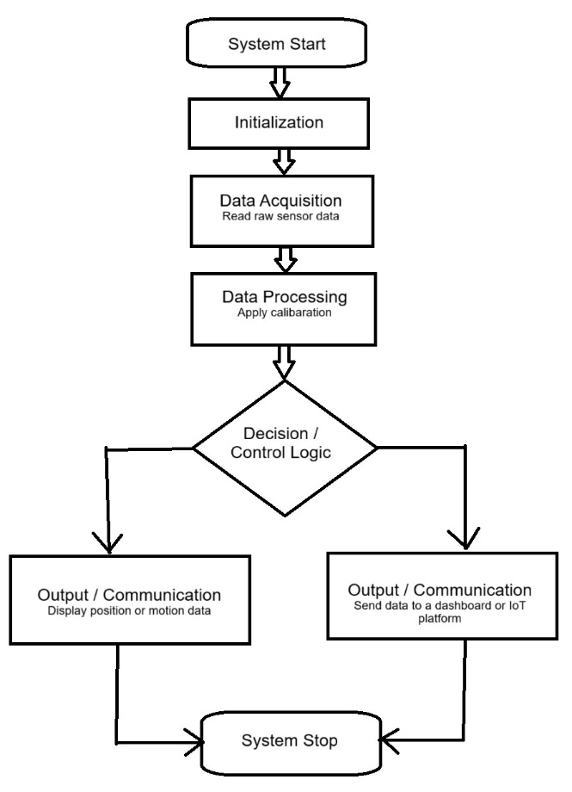
Fig. 2.1 The flowchart of system work
Systen Initialization:
The operation of the system begins with powering on the Raspberry Pi Zero 2W, which functions as the primary control and computation unit for the entire setup. Once powered, the Raspberry Pi boots its operating system and activates the necessary interfaces required for communication, most notably the I²C protocol used for establishing a connection with the MPU9250 motion sensors. Simultaneously, an external 5V power supply is used to energize the 16-channel PWM driver module, which is responsible for delivering precise control signals to the servo motors mounted on the acrylic robotic arm.
The use of a separate power source for the PCA9685 and servo motors ensures electrical isolation from the Raspberry Pi, preventing voltage drops or current spikes that could lead to instability or accidental system reset. As the system powers up, the Raspberry Pi performs a hardware scan to confirm the availability of connected peripherals, including the MPU9250 sensors and the PWM driver. Only after all devices are successfully detected and assigned communication addresses does the system transition into the next operational stage, guaranteeing that both sensing and actuation components are ready for operation.
Data Acquisition:
In this project, an MPU9250 IMU sensor is used to capture the motion of the hand. The MPU9250 is a compact, low-power sensor that combines accelerometer, gyroscope, and magnetometer functions, making it suitable for real-time motion tracking. The sensor is connected to a Raspberry Pi Zero, which serves as the main controller to process the data and run the necessary calculations.
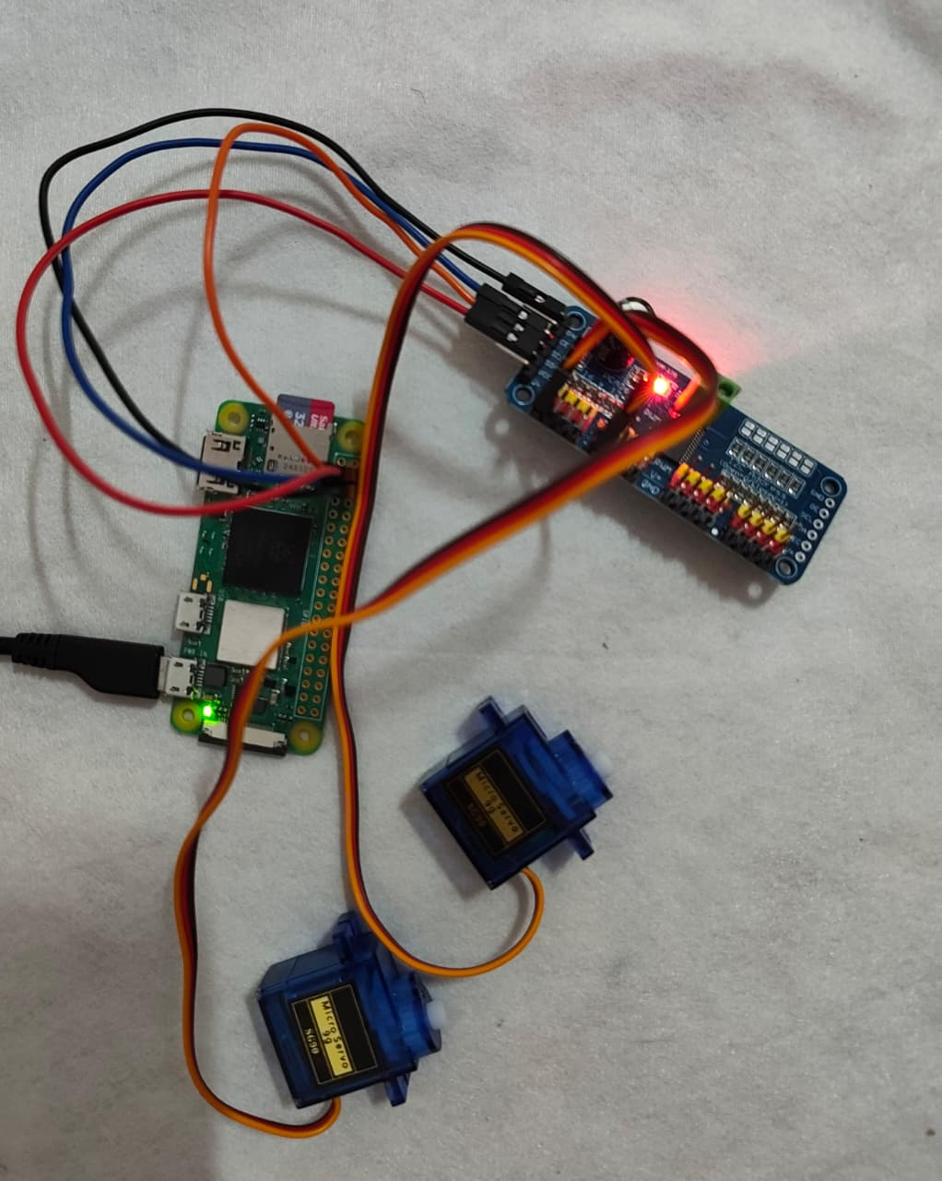
Fig 2.2 connectivity of sensor with servo motors with raspberry pi and 16-channel PWM driver
To drive the physical movement, a PCA9685 servo driver module is connected to the Pi. This module controls multiple micro servo motors, which act as actuators to replicate or respond to the detected hand motion. Figure 2.2 shows the hardware components used, including the Raspberry Pi Zero, the servo driver board, and the connected servo motors.
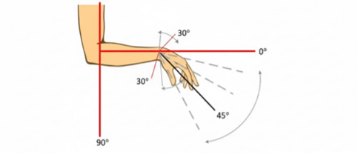
For accurate hand motion detection, correct placement of the IMU is important. The sensor needs to be placed at a point on the hand or wrist where it can clearly capture angular changes during natural movement. In this setup, the IMU is positioned in such a way that it can track Curling, extension, and rotation of the wrist joint. This allows even small changes in orientation to be detected and sent to the controller. Fig.2.3 illustrates the sensor placement on the hand.
Fig 2.3 Arrangement of hand joint and wrist movement
The hand movement is then crafted as angular motion, with a reference starting point set at a neutral (straight) wrist position. As the hand bends or rotates, the sensor captures the angular displacement, which is processed and mapped to control the servo motors. This enables the system to translate human hand motion into mechanical actuation. Fig. 2.3 shows the arrangement of hand joint movement.
Data Processing :
The system utilizes an MPU9250 IMU sensor for acquiring hand movement. The sensor is an accelerometer/gyroscope/magnetometer combination and has the capability to give real-time orientation and angular displacement. The IMU is connected with a Raspberry Pi Zero via the I²C protocol, which performs the acquisition and processing of data. To minimize noise and drift from the raw signals, filtering and sensor fusion methods are employed to facilitate precise estimation of the rotate, pitch, and roll angles of the hand.

The processed data is then translated to control signals by a PCA9685 servo driver module, which produces the PWM pulses that can be used to power micro servo motors. This provides the capability of converting perceived hand motion to mechanical actuation. Figure 2 illustrates the primary hardware modules, including the Raspberry Pi, the servo driver, and the attached servo motors.

For accurate tracking, the IMU sensor is located on the dorsal surface of the hand, in which it can register slight flexion, extension, and rotation motions. The neutral position of the wrist is used as the reference (0°), and angular displacement is stored whenever the hand bends or rotates. These angles are sent to the servo motors in real time, providing feedback corresponding to the actual motion of the hand. Figures 2.3 and 2.4 show the sensor placement and joint movement setup.

Reference :
[1] Lovanshi, M., Tiwari, V., Singh, A., & Ingle, R. (2024, December). Efficient Real-Time Human Activity Recognition with IoT Sensor Data Using Conditionally Parametrized Convolutions. In 2024 IEEE 4th International Conference on ICT in Business Industry & Government (ICTBIG) (pp. 1-6). IEEE.
[2]Umar, A., Tripathi, S., & Mahato, B. (2024, December). Feedback Simulation using IMU and Servo Motor. In 2024 1st International Conference on Sustainability and Technological Advancements in Engineering Domain (SUSTAINED) (pp. 232-238). IEEE.
[3]Kamaruzaman, K. A., Yahaya, S. Z., Noorsal, E., Boudville, R., Ahmad, F., & Soh, Z. C. (2023, August). Development of a sensory unit using a single IMU sensor for knee joint movement. In 2023, IEEE 13th International Conference on Control Systems, Computing and Engineering (ICCSCE) (pp. 353-357). IEEE.
[4]Mohammadi, M., Al-Fuqaha, A., Sorour, S., & Guizani, M. (2018). Deep learning for IoT big data and streaming analytics: A survey. IEEE Communications Surveys & Tutorials, 20(4), 2923-2960.
[5]Bharadwaz, P. J., Shaju, V. M., Jayanth, B. S., Chaitanya, D., Reddy, M. N., & Bukya, M. (2025, January). Electronic Circuit Design for an Autonomous Blimp Using Raspberry Pi Zero 2W. In 2025 International Conference on Next Generation Communication & Information Processing (INCIP) (pp. 1040-1043). IEEE.
[6]binti Rasidi, N. I., Al-Sanjary, O. I., Kashmola, M. Y., & Aik, K. L. T. (2022, December). Development on Autonomous Object Tracker Robot using Raspberry Pi. In 2022 IEEE 10th Conference on Systems, Process & Control (ICSPC) (pp. 29-33). IEEE.
[7]Agrawal, A. K., Kumar, J., Kumar, A., & Arvind, P. (2024, February). Enhancing human-robot interaction through PID control and sensor integration. In 2024 3rd International conference on Power Electronics and IoT Applications in Renewable Energy and its Control (PARC) (pp. 540-546). IEEE.
[8]Safa, A., & Al-Zawqari, A. (2024, December). Co-design of a robot controller board and indoor positioning system for IoT-enabled applications. In the 2024 International Conference on Microelectronics (ICM) (pp. 1-6). IEEE.
[9]Kapula, P. R., Deekonda, A., Dubey, S., Sushannth, B., Srikar, B. S., & Reddy, B. V. (2023, June). Design and Implementation of a Motion Imitation Robot. In 2023, the 5th International Congress on Human-Computer Interaction, Optimization and Robotic Applications (HORA) (pp. 1-5). IEEE
[10]Bingol, O., Tasdelen, K., Keskin, Z., & Kocaturk, Y. E. (2014). Web-based smart home automation: PLC-controlled implementation. Acta Polytechnica Hungarica, 11(3), 51-63.
[11]Sztipanovits, J., Koutsoukos, X., Karsai, G., Kottenstette, N., Antsaklis, P., Gupta, V.,…& Wang, S. (2011). Toward a science of cyber–physical system integration. Proceedings of the IEEE, 100(1), 29-44
[12]Pillai, A. S., & Raj, A. (2022, October). Modeling & Verification of an Adaptive IoT System using Uppaal. In 2022 IEEE 3rd Global Conference for Advancement in Technology (GCAT) (pp. 1-5). IEEE
[13]Stern, R. E., Cui, S., Delle Monache, M. L., Bhadani, R., Bunting, M., Churchill, M.,
... & Work, D. B. (2018). Dissipation of stop-and-go waves via control of autonomous vehicles: Field experiments. Transportation research part C: emerging technologies, 89, 205-221.
[14]Mishi, M. R., Bibi, R., & Ahsan, T. (2017, February). Multiple motion control system of robotic car based on IoT to produce cloud service. In 2017 International Conference on Electrical, Computer and Communication Engineering (ECCE) (pp. 748-751). IEEE.
[15]Koyasako, Y., Suzuki, T., Kim, S. Y., Kani, J. I., & Terada, J. (2020, January). Real-time motion control method using measured delay information on access edge computing. In 2020 IEEE 17th Annual Consumer Communications & Networking Conference (CCNC) (pp. 1-4). IEEE.
[16]Wang, W. (2013). Status and development trend of inertial technology. Acta Automatica Sinica, 39(6), 723-729
[17]Umar, A., Tripathi, S., & Mahato, B. (2024, December). Feedback Simulation using IMU and Servo Motor. In 2024 1st International Conference on Sustainability and Technological Advancements in Engineering Domain (SUSTAINED) (pp. 232-238). IEEE.
[18]Perissinotto, C. M., Cenzer, I. S., & Covinsky, K. E. (2012). Loneliness in older persons: a predictor of functional decline and death. Archives of internal medicine, 172(14), 1078- 1084.
[19]Wang, C., & Nonaka, T. (2021, October). Monitoring System for Balance Board
Simulating Side-riding Board Sports. In 2021 IEEE 10th Global Conference on Consumer Electronics (GCCE) (pp. 415-416). IEEE.
[20]Moriya, K., Nakagawa, E., Fujimoto, M., Suwa, H., Arakawa, Y., Kimura, A., ... & Yasumoto, K. (2017, March). Daily living activity recognition with Echonet Lite appliances and motion sensors. In 2017 IEEE International Conference on Pervasive Computing and Communications Workshops (PerCom Workshops) (pp. 437-442). IEEE.
[21]Raja, G., Essaky, S., Ganapathisubramaniyan, A., & Baskar, Y. (2022). Nexus of deep reinforcement learning and leader–follower approach for AIoT enabled aerial networks. IEEE Transactions on Industrial Informatics, 19(8), 9165-9172.

